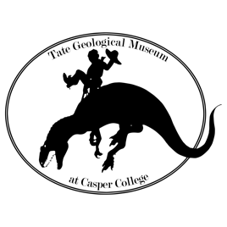

Tate Geological Museum’s Dinosaur Dig Registration

Summer 2025

Please check the applicable boxes and fill in the costs. The registration fee and completed medical release form are required to hold your place. The registration fee is due no later than 60 days prior to the start of the dig. Minimum age for participation is 16 (16 and 17-year-olds must be accompanied by an adult participant). Registration includes a one-year membership to the museum.

**Preferred Week: select one**

**July 7-11 August 25-29 September 8-12**

**If paying by check If paying by credit card**

___Registration (with shared room) $1250.00 ___Registration (with shared room) $1287.50

___Single room is an additional $350.00 ___Single room is an additional $360.50

___Donation $______ ___Donation $______

TOTAL $______ TOTAL $______

*Credit card costs reflect a 3% processing fee. If paying by credit card we will call you at the phone number listed below for your card information when we receive your completed forms. Please do not send credit card information through the mail or email.*

Please complete the following: Please print clearly!

Name: Address:__________________________________City, State, Zip Cell Phone Number (yours, please): Email:

Date of Birth:

Male:

Female:

Please specify any dietary requirements or allergies: Mail completed this form, the release form and payment to:

Tate Geological Museum Dinosaur Dig

125 College Drive

Casper, WY 82601

Attn: JP Cavigelli

NOTE: There is additional paperwork to fill out if you would like to drive your own vehicle (or a rental car) at any point during the dig week. You will need to submit a “Drive My Own Vehicle” form, a copy of your current driver’s license and current insurance at least 30 days prior to arriving. Email JP at [jpcavigelli@caspercollege.edu](mailto:jpcavigelli@caspercollege.edu) to request the forms. If you do not plan to drive, vehicles can be left at the museum or the Ramkota Hotel in Casper.